Name: |  | ___________________________________________________ |  |  |  | Date: ___________
 |  | Year 9 Mathematics  Test 10, 2015  Topics - Trigonometry |  |  |  | 60  =______ %
Total Time: |  | 60 minutes
Total Reading: |  | 5 minutes
Total Working: |  | 55 minutes
Weighting: |  | ______% of the year.
Equipment: |  | Curriculum Council Formula Sheet; ½ page notes (A4 one side), CAS calculator; Scientific Calculator
CALCULATOR ALLOWED
1. | [2 marks: 1, 1]
 | Label the sides Hypotenuse, Opposite and Adjacent on the following right angled triangles:
a) |  |  |  | b)
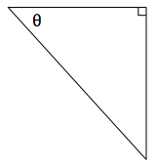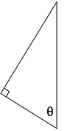

2. | [2 marks: 1, 1]
 | Label the angle in the correct place on the following right angled triangles:
a) |  | b)
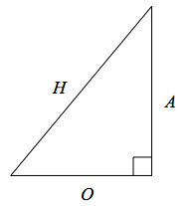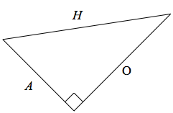

3. | [8 marks: 2, 2, 2, 2]
 | Calculate the length of the missing side for each right angled triangle:
a) | 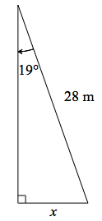 | b) | 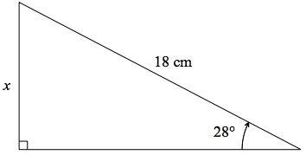
c) | 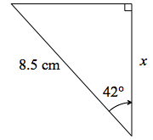 | d) | 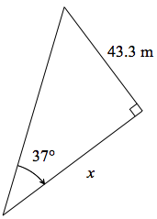

4. | [8 marks: 2, 2, 2, 2]  Calculate the length of the missing side for each right angled triangle:
a) | 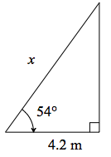 | b) | 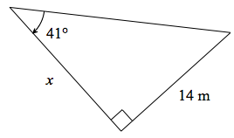
c) | 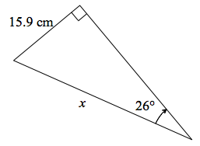 | d) | 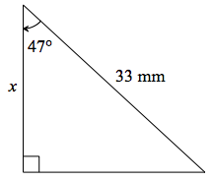
5. | [8 marks: 2, 2, 2, 2]  Calculate the size of the missing angle for each right angled triangle:
a) | 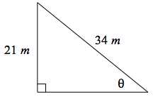 | b) | 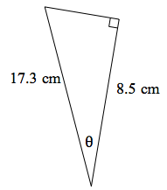
c) | 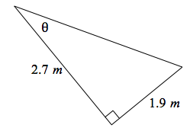 | d) | 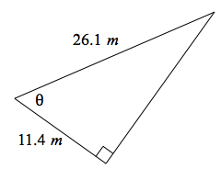

For each worded question fill in the measurements on the given diagram.
6. | [9 marks: 3, 3, 3]
a) | A person stands 12.5 m from the base of a building, the angle of elevation to the top of the building is .  What is the height of the building?
 | 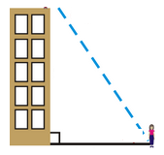
b) | Find how far the person is standing from the 4.2m tall traffic lights.
 | 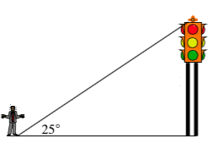
b) | A 25 m flagpole casts a 42 m shadow. What is the angle the sun makes with the flagpole
 | 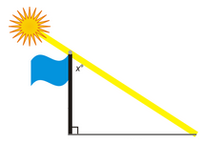
7. | [6 marks: 3, 3]
a) | Noah sees the 96 m tall tower Big Ben from 400 m away. At what angle of elevation does he view it?
 | 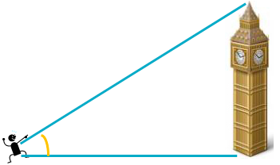
b) | A hot air balloon is tethered to the ground by a a 275m rope which creates an angle to the ground of . How high above the ground is the balloon?
 | 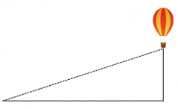
8. | [5 marks]
Jessie walked from A to B to C.
Linh walked from A to C.
How much further did Jessie walk?
 | 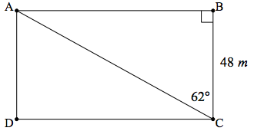
9. | [6 marks: 3, 3]
a) | A flagpole stands on level ground. From a point 40 m from its base, the angle of elevation to the top of the pole is . How tall is the flagpole?  (Sketch a diagram of the scenario)
b) | Two buildings are directly opposite one another either side of a 15 m wide street. One building is 22 m tall and the other is 41 m tall. Find the angle of elevation from the top of the shorter building to the top of the taller building.  (Sketch a diagram of the scenario).

10. | [6 marks: 3, 3]
a) | A person flying a kite holds the string 1.2 m above level ground, at an angle of elevation of . If the string is 45 m long, what is the height of the kite above ground level.  (Sketch a diagram of the scenario).
b) | From the top of a 25 m lighthouse, on a 314 m tall cliff, the angle of depression to a sailing boat out in the ocean is 40°. How far is the sailing boat from the base of the cliff?  (Sketch a diagram of the scenario).
~ END OF TEST ~

